

CareConnect
Senior Project By

Semaan Antonios

Submitted to the School of Arts & Science of the Lebanese International University

In part of fulfillment of the requirements for the degree of
BACHERLOR OF SCIENCE IN
COMPUTER SCIENCE .

Supervised by: Dr. Mohamad Saade

Fall 2025-2026

Dedication:

This project is dedicated to our families for their continuous support and encouragement throughout our academic journey.
We also dedicate this work to our instructors who guided us with their valuable knowledge and feedback.
Their motivation and patience played a major role in completing this project successfully.
Without their support, this achievement would not have been possible.

Acknowledgment:

We would like to express our sincere gratitude to our supervisor and instructors for their guidance and constructive feedback.
Special thanks to our university for providing the resources and learning environment needed to complete this project.
We also appreciate our teammates for their cooperation, dedication, and teamwork.
Finally, we thank everyone who supported us directly or indirectly during the development of this system.

Abstract:

Care Connect Management System is a web-based Hospital Management System designed to improve healthcare service organization and communication.
The system allows users to create accounts, browse hospital profiles, and book appointments with real-time notifications.
Administrators and hospitals can manage roles, appointments, medical staff, equipment, services, and payments efficiently.
This system aims to enhance operational efficiency, transparency, and overall user experience in the healthcare sector.

Table of Contents:
Contents
Dedication… II
Acknowledgment III
Abstract IV
List of Tables V
List of Images VI
Chapter 1 11
1.1-Introduction: 11
1.2-Objective: 11
1.3-Scope: 12
1.4-Technology Constraints 12
Software needed: Visual studio code, Xampp, Web browser 12
1.5-Problem 13
1.6-Solution 13
Chapter 2 14
2.1-Functional and Conceptual Study 14
2.1.1-Functional Requirements 14
2.1.2-Nonfunctional requirements 15
2.2-UML Use Case Diagram & Scenario 16
2.2.1-Use Case Diagram 16
2.2.2-Use Case scenarios (customer actor) 18
2.2.3-Use Case scenarios (Admin actor) 30
Chapter 3 34
3.1-System Design: 34
3.1.1-ER-Diagram 34
ER Diagram Figure: 35
Relational Diagram Figure: 36
Chapter 4 37
Implementation: 37
4.1-Introduction: 37
4.2- Project’s Parts: 38
4.2.1-Home Page: 38
4.2.2- services Page: 39
4.2.3- Doctors Page: 40
4.2.4- Hospital Page + Create Appointment: 41
4.2.5- Notification 42
4.2.6- Contact 43
4.2.7- Appointment + Payment 44
4.2.8- Hospital Start Page: 45
4.2.9- Equipment Page: 46
4.2.10- Notification Page: 47
4.2.11- Services Page: 48
4.2.12- Payment Page: 49
4.2.13- Dr + Nurse Page: 50
4.2.14- Contact Page + Profile Page: 51
4.2.15- Admin Manage users Page: 52
4.2.16- Manage Messages: 53
4.2.17- Manage Notification: 54
4.2.18- Manage hospitals: 55
4.2.19- :Login & Register Page 56

Chapter 5 70
  - Conclusion: 70
  - Future Work 70
References 71

Chapter 1
In this chapter, we are going to state the problem that we find, and how our project helps in solving it, in addition to mentioning technology constraints and our objective, then explaining all of them in details.

1.1-Introduction:

Care Connect Management System is a web-based Hospital Management System designed to simplify and enhance healthcare service management.
The system connects users, hospitals, and administrators through a centralized digital platform.
It supports role-based access, appointment scheduling, notifications, and hospital resource management.
By automating key processes, the system improves efficiency, communication, and overall healthcare service quality.

1.2-Objective:
- To centralize healthcare services through a unified hospital management platform.
- To implement secure authentication and role-based access control.
- To automate appointment scheduling, confirmation, and cancellation processes.
- To enable efficient management of hospital resources and staff.
- To enhance communication using real-time notifications and payment handling.

1.3-Scope:
The scope of Care Connect Management System covers user registration, authentication, and role management.
It includes hospital profile management with doctors, nurses, equipment, and services.
The system supports appointment booking, confirmation, cancellation, and notification delivery.
Administrative functionalities such as role assignment and system monitoring are included.
The platform also integrates payment processing related to hospital appointments and services.

1.4-Technology Constraints:

Software needed: Visual studio code, Xampp, Web browser

Frameworks & libraries: React js & tailwinds css
backend framework: node js + express js
Hardware: laptop.

1.5-Problem:
- Difficulty in managing hospital appointments efficiently using traditional or manual systems.
- Lack of centralized platforms that connect users, hospitals, and administrators.
- Poor communication between patients and hospitals regarding appointment status and updates.
- Limited access to accurate and up-to-date information about hospital services and staff.
- Inefficient management of hospital resources such as doctors, nurses, and medical equipment.

1.6-Solution:
  - Implementing an automated appointment management system with confirmation and cancellation features.
  - Providing a centralized web-based platform for users, hospitals, and administrators.
  - Enabling real-time notifications to improve communication and reduce delays.
  - Allowing users to view detailed hospital profiles, services, and available staff.
  - Offering hospital-side management tools for efficient control of resources, payments, and appointments.

Chapter 2
This chapter describes both functional and non-functional requirements for our project. In addition to that it shows the UML use cases and scenarios with all related details.
2.1-Functional and Conceptual Study

2.1.1-Functional Requirements:

  - The system shall allow Patients to register, log in, and log out.
  - The system shall allow Patients to manage appointments (create/request, view, update, cancel).
  - The system shall allow Patients to send messages to the hospital/admin and receive notifications.
  - The system shall allow Patients to make payments and view payment status/receipts.
  - The system shall allow Admins to manage users (add/update/delete/search) and manage the hospital profile.
  - The system shall allow Admins to manage appointments, messages, and notifications, and generate/view reports.
  - The system shall allow Hospital Staff to manage doctors, nurses, services, and equipment.
  - The system shall allow Hospital Staff to receive and process appointment requests and confirm/record payments.

2.1.2-Nonfunctional requirements:

- Security: The system shall enforce authentication and role-based access control (Admin/Patient/Staff) and encrypt sensitive data.
- Performance: Common actions (login, appointment view, messaging) should respond within acceptable time under normal load.
- Availability: The system should be available with minimal downtime and support recovery from failures.
- Usability: The interface shall be easy to use on desktop and mobile with clear navigation and error messages.
- Reliability & Data integrity: The system shall prevent data loss, ensure consistent appointment/payment records, and maintain audit logs for critical actions.
- Scalability: The system shall support growth in users, appointments, and messages without major redesign.
- Maintainability: The system shall be modular, documented, and easy to update (e.g., add new services or notification types).
- Compliance & Privacy: The system shall follow applicable healthcare/payment privacy rules and store only necessary personal data.

2.2-UML Use Case Diagram & Scenario
2.2.1-Use Case Diagram

The use case diagram describes a Hospital Management System with three main actors: Admin, Patient, and Hospital Staff.
The Admin logs in to manage users, hospital profile, appointments, messages, notifications, and system operations.
The Patient can register, log in, manage appointments, send messages, make payments, and receive notifications.
The Hospital Staff logs in to manage doctors, nurses, equipment, and services, and to receive appointments and payments.
Most system functionalities require authentication through a login process before access is granted.
Each actor can securely end their session using the appropriate logout function.
.

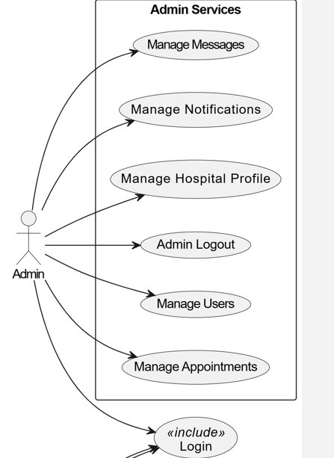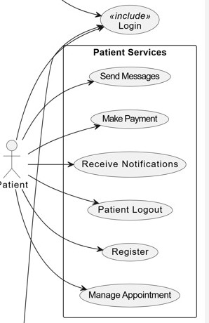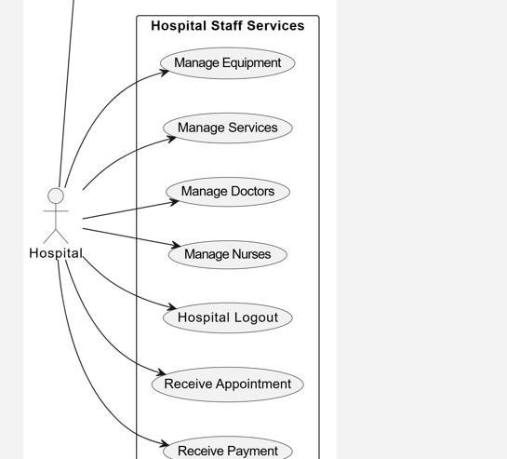

2.2.2-Use Case scenarios (customer actor)

In this part we will be explaining all of the mentioned use cases of the users in details, regarding primary actors, main flow, and the alternative one. In addition to a short description for each use case making all points clear.

Table 1 Manage Appointment

Use case ID: | UC-PA-01
Use case name: | Manage Appointment
Created by: | Louay Mahmoud & Semaan Anthonios
Date created: | 25 dec 2025

Description: | This use case allow patient to create view update or cancel an appointment with the hospital through the system
Primary actor: | patient
Secondary actor: | Hospital staff
Included use cases: | Login
Extended use cases: | Receive Appointment
Preconditions: | User is not registered  The patient must be logged in to the system
Post conditions: | The appointment request is successfully created,updated,or cancelled  The hospital staff is notified of the appointment action
Main flow: | - the patient login in to the system  - the patient select manage appointment options  - the patient select an appointment  - the patient confirm the appointment details  - The use case ends

Alternative flow: | - if the selected time slots is unavailable the system displays an error .  - if the patient cancel the operation no changes no saved and the system return to the main menu

Table 2 – Manage users

Use case ID: | UC-A01
Use case name: | Manage Users
Created by: | Louay Mahmoud & Semaan Anthonios
Date created: | 25 December 2025

Description: | Allow admin to manage users activate deactivate them and change the role for users
Primary actor: | Admin
Secondary actor: | none
Preconditions: | Admin account exist and the user is logged in
Post conditions: | User activated deactivated successfully from the system
Main flow: | - Admin login to the system  - Admin select manage users  - The system display the list of users  - The admin click deactivate or change role  - The system update user status and role  - The use case end
Alternative flow: | - if required data missing or invalid the system display user not found

Table 3 – Receive Notification

Use case ID: | UC-P-02
Use case name: | Make Payment
Created by: | Louay Mahmoud & Semaan Antonios
Date created: | 25 December 2025

Description: | Enable patient to pay for hospital services or appointment through the system
Primary actor: | patient
Secondary actor: | hospital
Preconditions: | The patient is logged in and has a pending payment
Post conditions: | Payment is recorded successfully and staff can view payment status
Main flow: | - The patient is logged in to the system  - The patient click on pay now in appointment  - The patient select a payment complete  - the patient enter payment method  - the system process payment and transactions
Alternative flow: | - if the payment fails the system show failure reason and allow retry  - The use case end.

Table 4 – Send Messages

Use case ID: | UC-P03
Use case name: | Send Messages
Created by: | Louay Mahmoud & Semaan Antonios
Date created: | 25 Dec 2025

Description: | Allows the Patient to send inquiries or messages to the hospital/admin through the system.
Primary actor: | Patient
Secondary actor: | Admin
Preconditions: | The patient is logged in
Post conditions: | Messages is stored and delivered to admin inbox
Main flow: | - The patient login to the systems  - The patient click on contact us  - The system display message form  - The patient write a messages and submit it  - The system validate content and messages  - admin is receive a new notification  - use case end
Alternative flow: | - if the message content is empty the system display a messages error  - if the system fails to save it show error and allow resubmission

Table 5 – Manage Doctor

Use case ID: | UC-H-01
Use case name: | Manage Doctors
Created by: | Louay Mahmoud & Semaan Anthonios
Date created: | 25 dec 2025

Description: | Enable hospital to add update delete doctors
Primary actor: | hospital
Secondary actor: | none
Extended use cases | None
Preconditions: | Staff user is logged in
Post conditions: | The doctor record are updated and saved succesfully
Main flow: | - The hospital login in to the system  - The hospital select manage dr  - The system display dr list  - The system validate entered data  - the system save data and confirm sucecss
Alternative flow: | - if invalid data is entered the system display error messages  - if stuff try to delete doctor link to appointment the system block deletion

Chapter 3
This chapter describes the system design, including the data base of our project, the related tables and the relations between them.

3.1-System Design:

3.1.1-ER-Diagram

This ERD models a Hospital Management System where Users (patients/admin/staff) interact with hospitals and services. Each Hospital is linked to a user account and can own multiple Services and Equipment records. Patients (Users) can book Appointments with a specific Hospital and Doctor, and each appointment stores its status and date. Payments are recorded per user and hospital and can be linked to a specific appointment, including payment method and payment status. The system also supports communication and updates through Contact Messages (user inquiries) and Notifications (messages delivered to users with read/unread tracking).

Hospital Management System entities and their attributes (from the ERD)

Users: id, username, email, password, dob, user_role
Primary Key: id

Hospitals: hospital_id, user_id, name, address, phone, email, image
- Primary Key: hospital_id
- Foreign Key: user_id → Users(id)

Doctors: doctor_id, equipment_id, name, specialization, phone, email, image
  - Primary Key: doctor_id
  - Foreign Key: equipment_id → Equipment(equipment_id)
. Nurses: nurse_id, equipment_id, hospital_id, name, phone, email, image
  - Primary Key: nurse_id
  - Foreign Keys: equipment_id → Equipment(equipment_id), hospital_id → Hospitals(hospital_id)
Services: service_id, hospital_id, title, description, image
- Primary Key: service_id
- Foreign Key: hospital_id → Hospitals(hospital_id)

Equipment: equipment_id, hospital_id, name, description, image
- Primary Key: equipment_id
- Foreign Key: hospital_id → Hospitals(hospital_id)

Appointments: appointment_id, user_id, hospital_id, doctor_id, status, appointment_date
- Primary Key: appointment_id
- Foreign Keys: user_id → Users(id), hospital_id → Hospitals(hospital_id), doctor_id → Doctors(doctor_id)

Payments: payment_id, user_id, hospital_id, appointment_id, payment_method, status
- Primary Key: payment_id
- Foreign Keys: user_id → Users(id), hospital_id → Hospitals(hospital_id), appointment_id → Appointments(appointment_id)
Notifications: id, user_id, title, message, is_read
- Primary Key: id
- Foreign Key: user_id → Users(id)
Contact_Messages: id, user_id, fullname, email, subject, message
- Primary Key: id
- Foreign Key: user_id → Users(id)

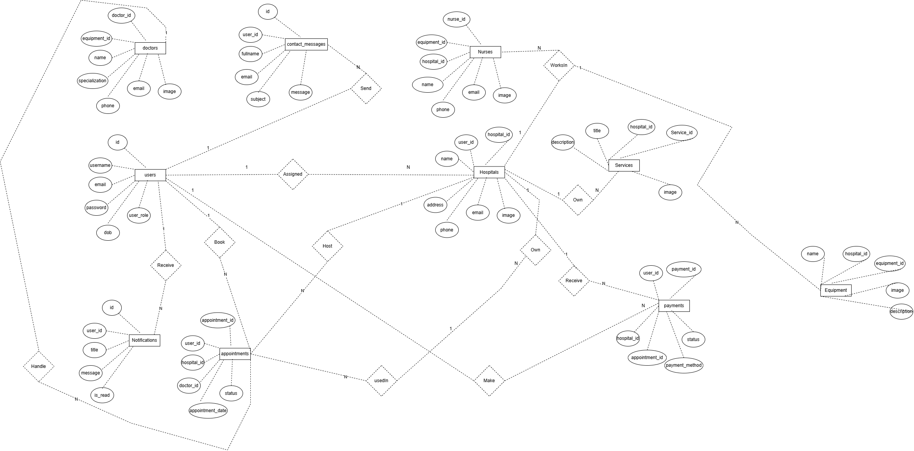

Relational Diagram Figure:
See all the attributes of each entity, in addition to the relations between entities.

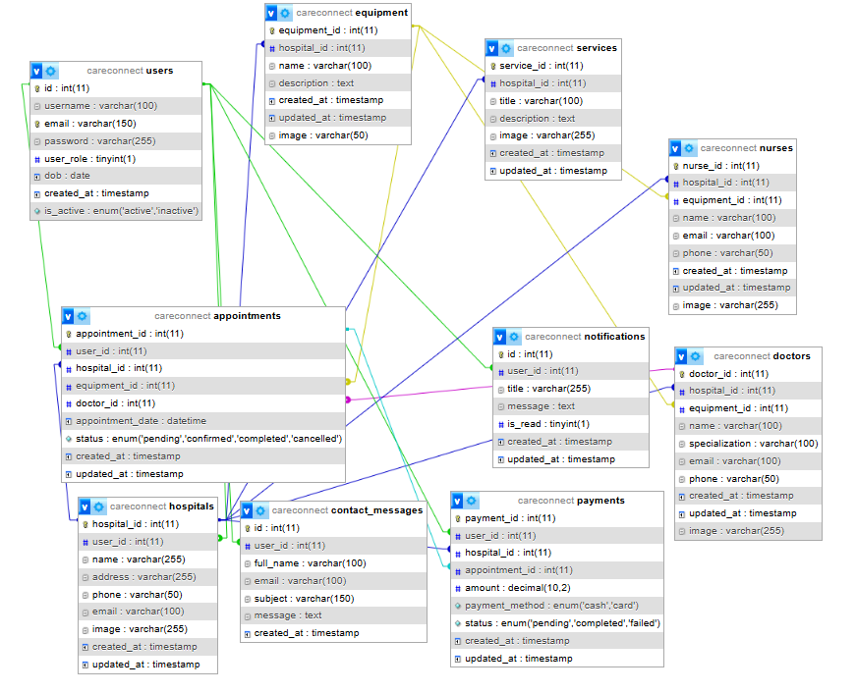

Chapter 4
This chapter describes the whole view of our website, it shows the design our projects in addition to stating the main role of each page or button.

Implementation:

4.1-Introduction:

This chapter presents the design and implementation of the user interface of the Care Connect Management System. It explains how different system pages are structured and how users interact with the platform based on their assigned roles. The chapter focuses on the navigation flow, main interface components, and key functionalities available to users, hospitals, and administrators. Additionally, it demonstrates how the system supports appointment management, notifications, hospital profiles, and resource management through a user-friendly and responsive interface. The following sections provide a detailed view of each webpage and describe how the Care Connect Management System operates visually and functionally.

4.2- Project’s Parts:

4.2.1-Home Page:
this is the start page when user enter the website and they can see available services dr by click on link and he can create account by click sign in sign up
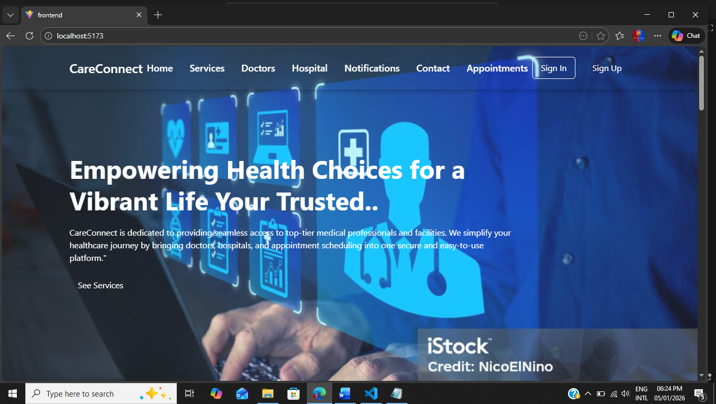

4.2.2 Services Pages
In this page user they can see available services provided by our website

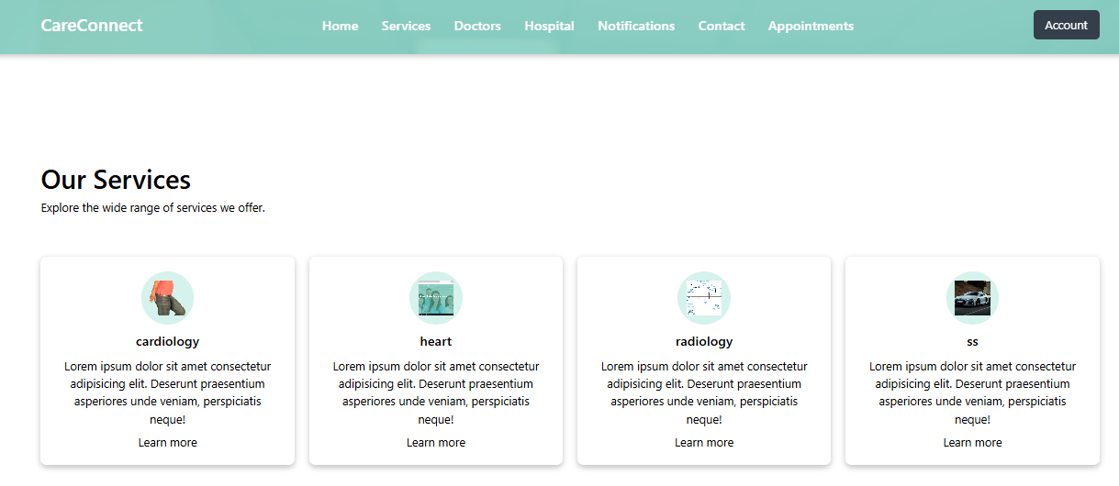

4.2.3 Doctors Page
This section displays the available doctor provided in our website
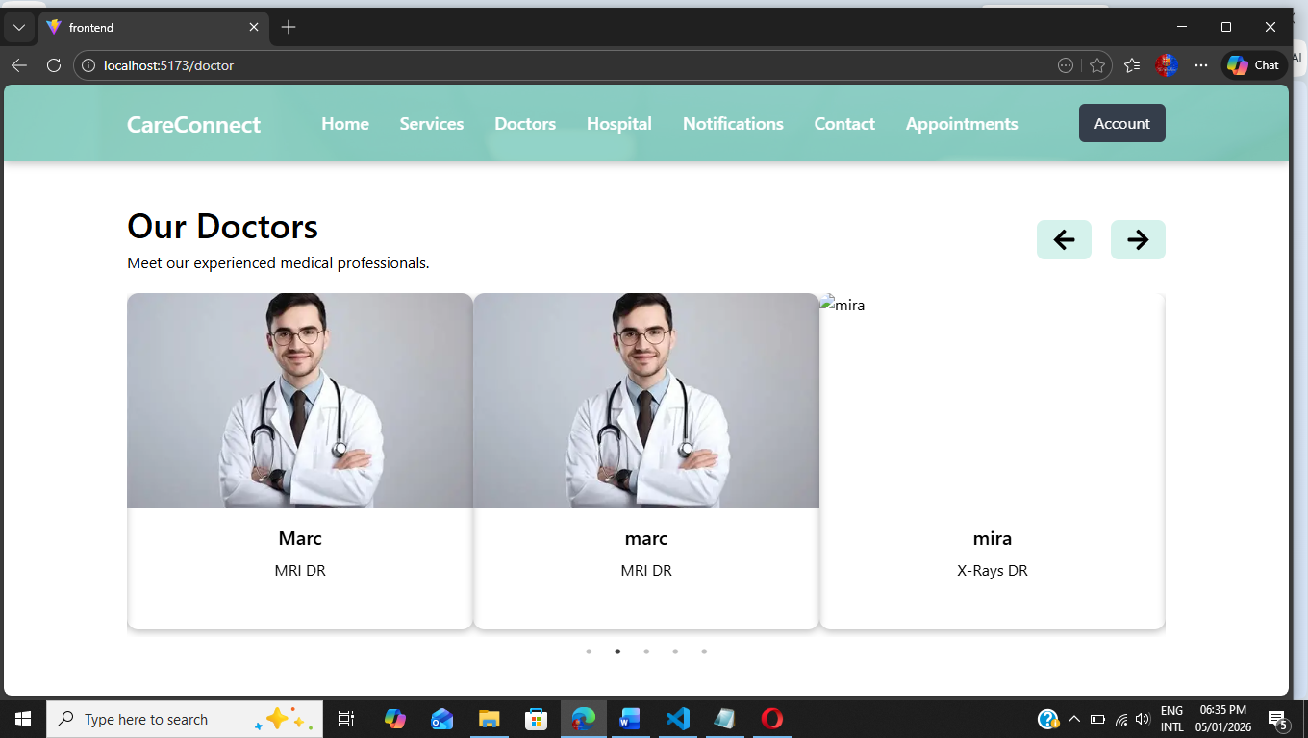

4.2.4 hospital && create appointment page

in this page user they can see our hospital and they can create appointment by select equipment nurses doctor in each nurses and the click create appointment
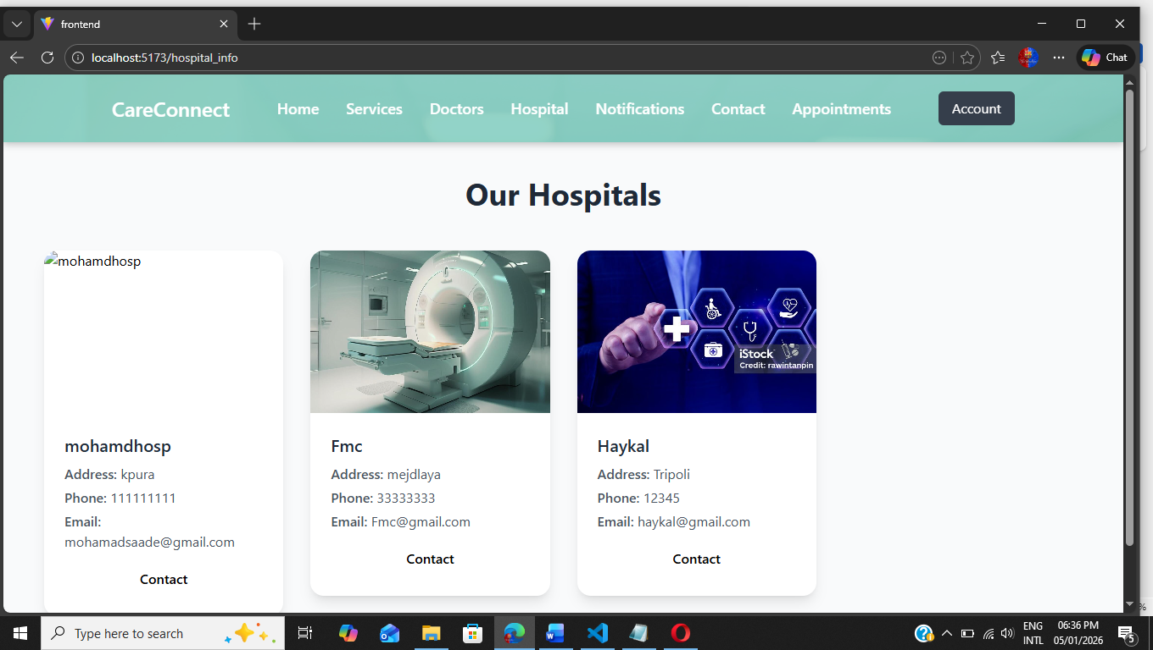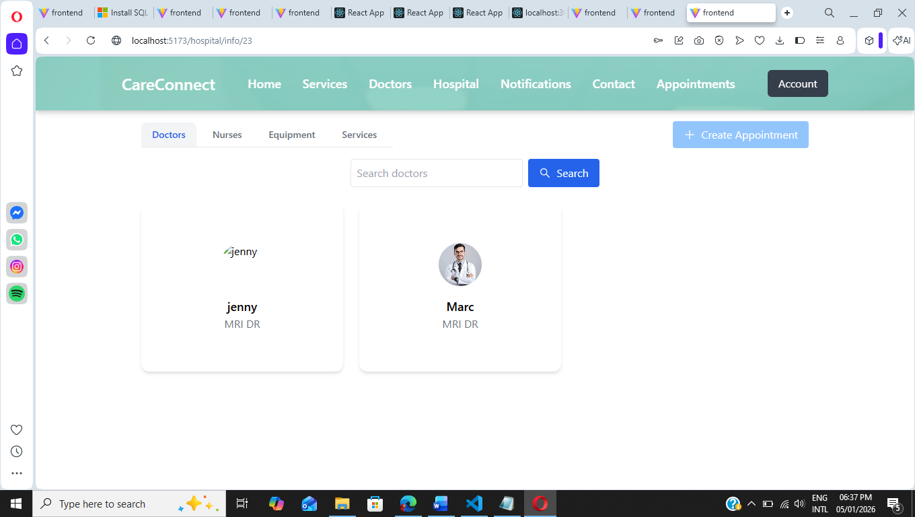

4.2.5- Notification Page:
Here in this page user they can see received notification from website like appointment confirmation reply to messages and so on

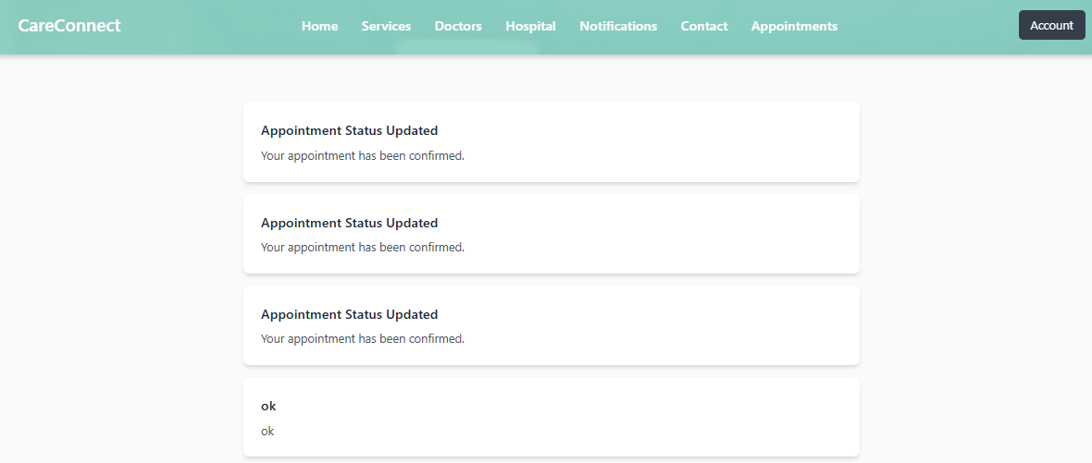

4.2.6- contact us page:
in this page user they can send notification messages to the admin if there is any feedback or something

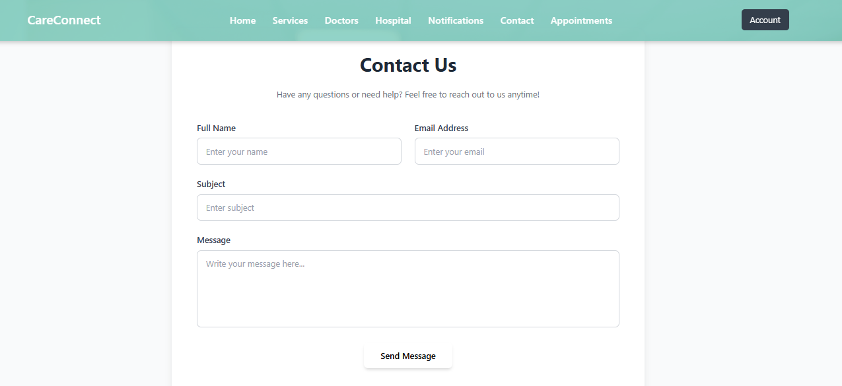
4.2.7- Appointment && Payment Page
here in those page user they can see created appointment in hospital once hospital confirm appointment the cancel btn it will changed to pay now once user click on pay now he will be redirected to the next pages which is for payments and they can pay with cash or card

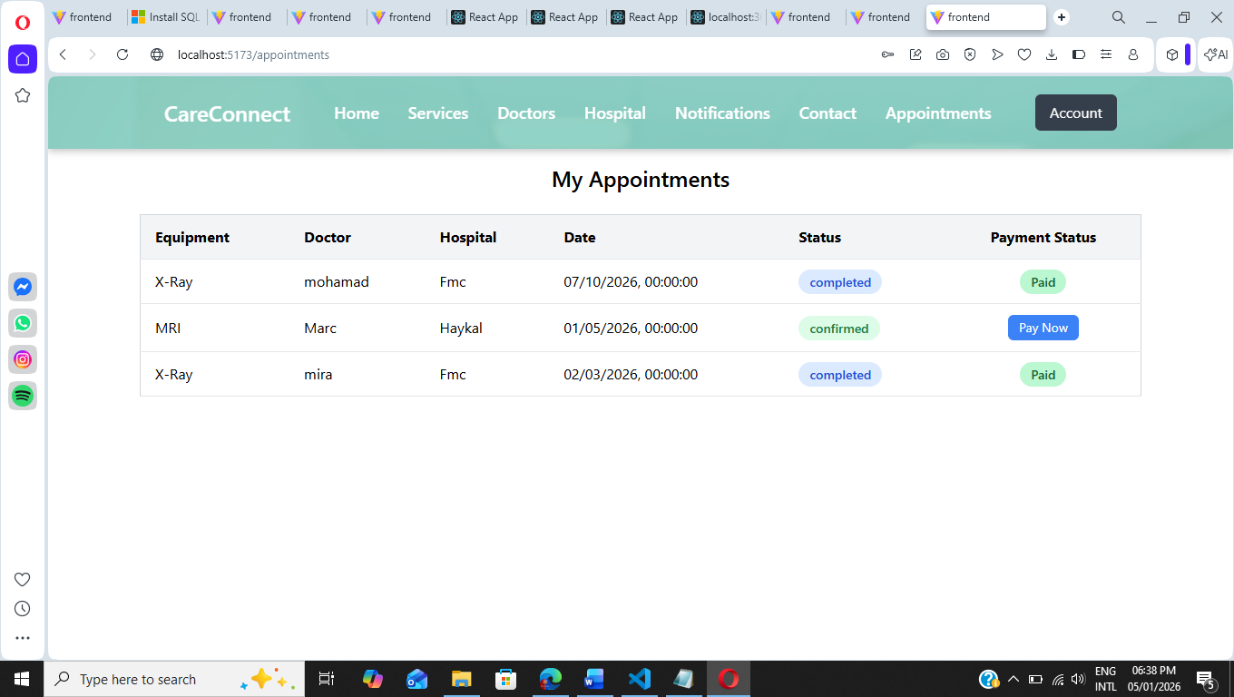

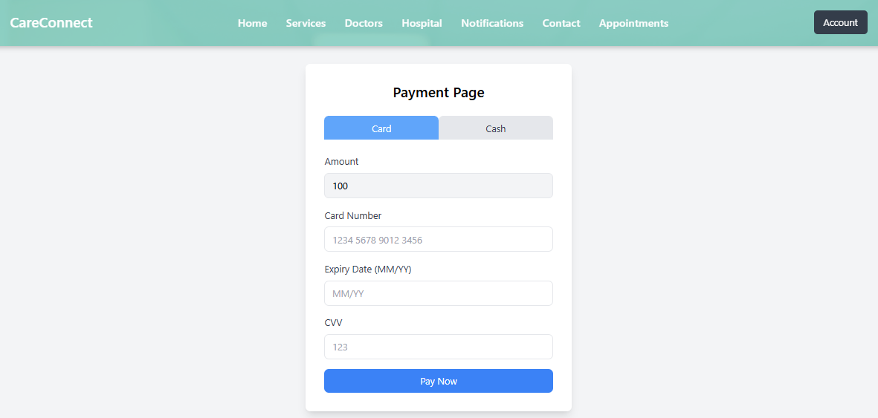

4.2.8- Hospital Start Page
once user logged in as hospital he will be redirected to this page to manage appointment include confirm cancel with notification sended to the user
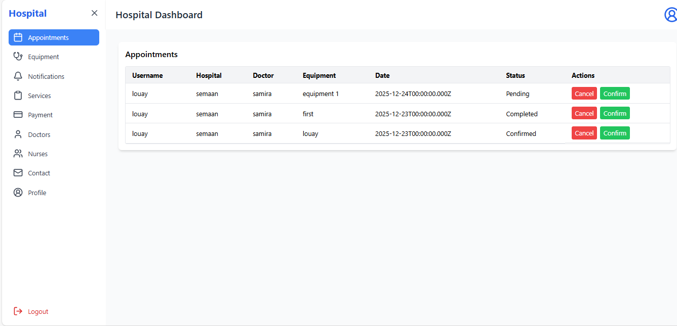

4.2.9- Equipment Page:
in this page hospital it can see available equipment include add update deleted
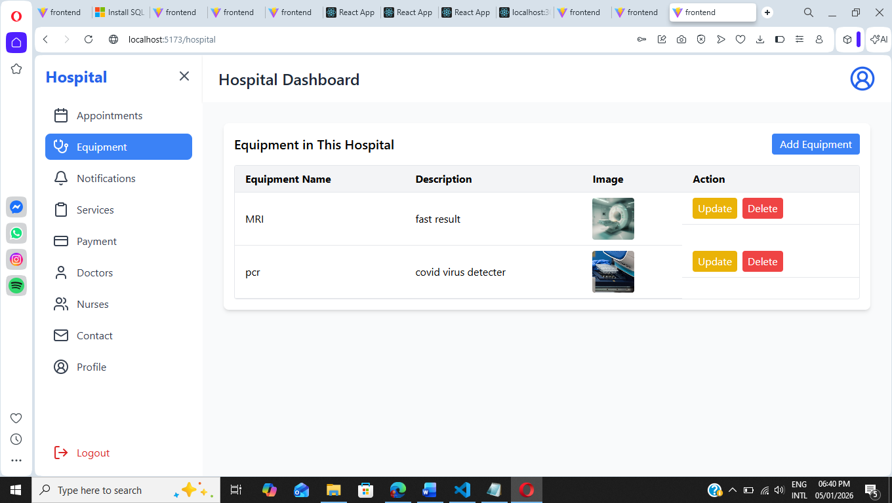

4.2.10 Notification hospital Page

in this page hospital it can see available notification received and they can marked as read once it marked the mark as read btn it will be hidden and then it changed to delete btn

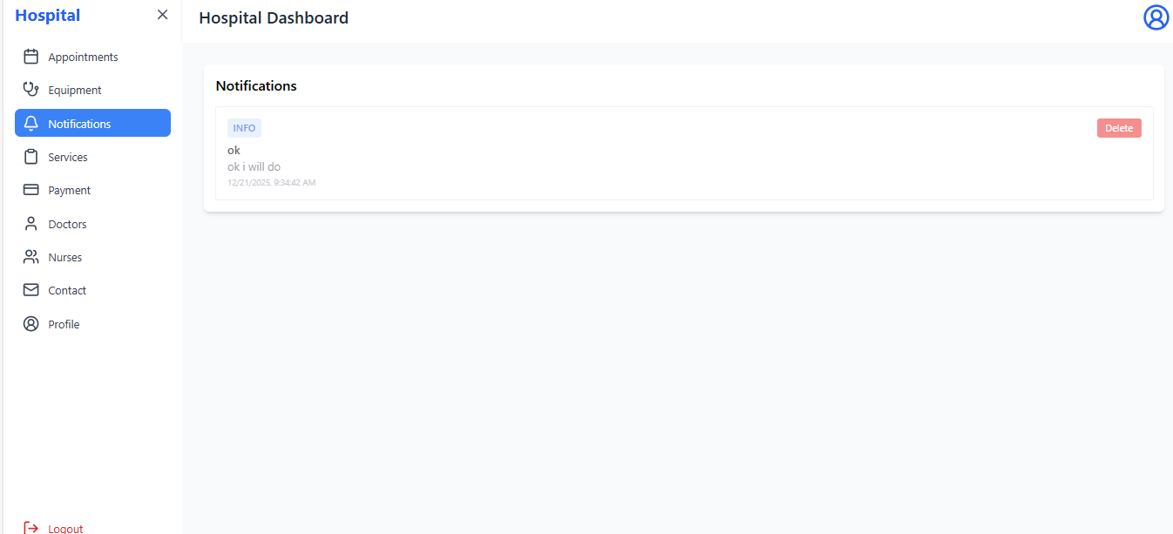
4.2.11- Services Page:
in this page hospital it can manage services include add update delete

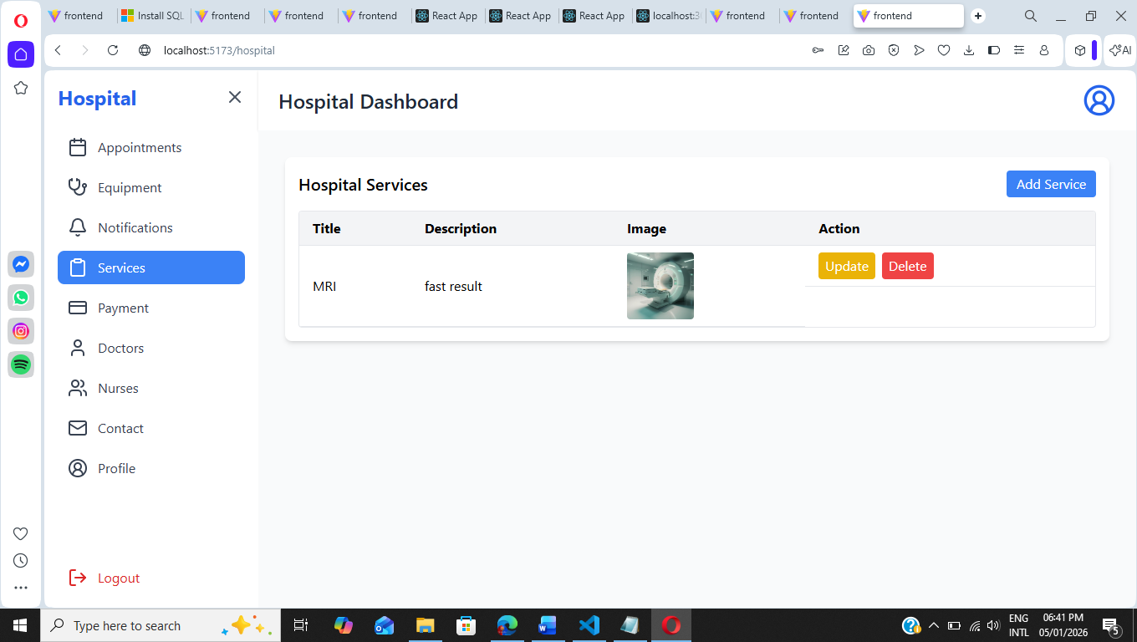
4.2.12- Payment Page:
In this Page hospital it can see received payment from appointment

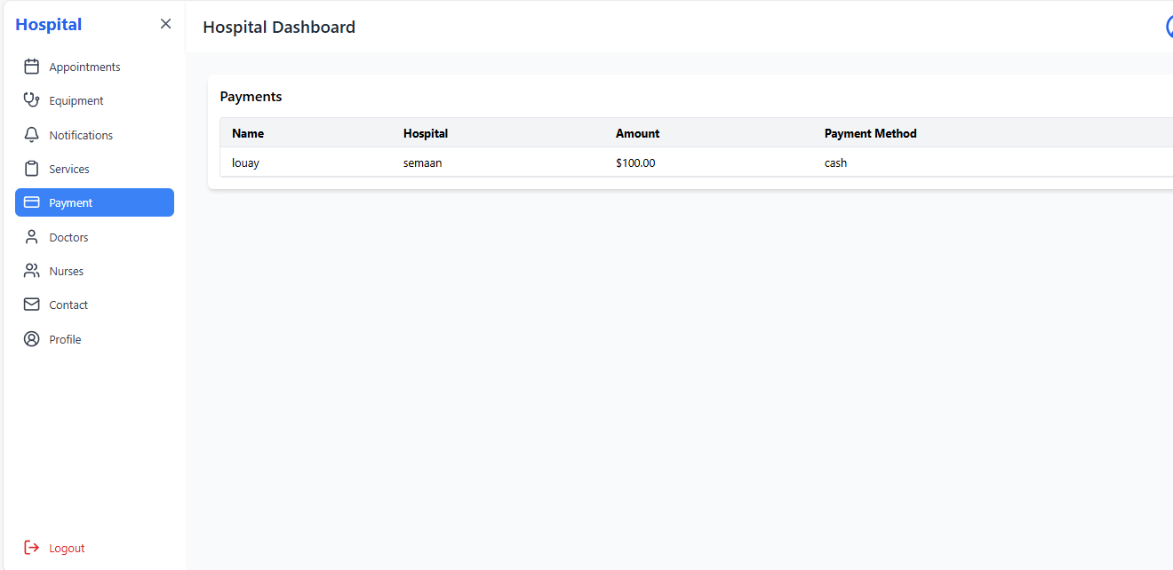

4.2.13-Dr && Nurse Page:
in this page hospital it can manage as u see dr & nurse include add update delete dr & nurse

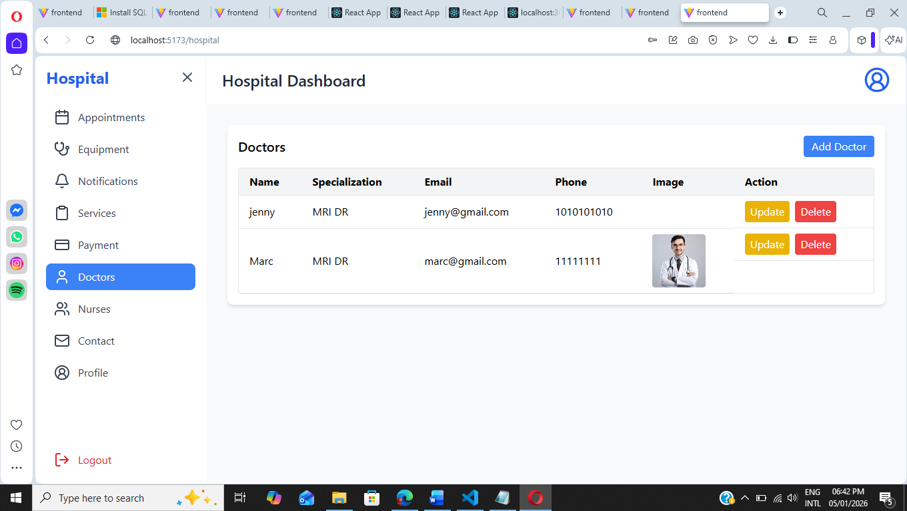

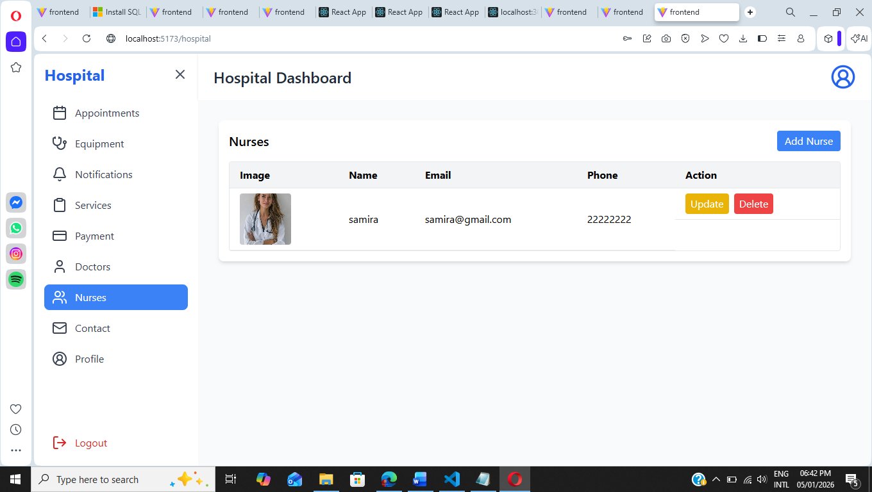

4.2.14 Contact Page && Profile Page
in this page user they can send contact messages to the hospital if there is any services or feedback also for profile page they can add update delete profile
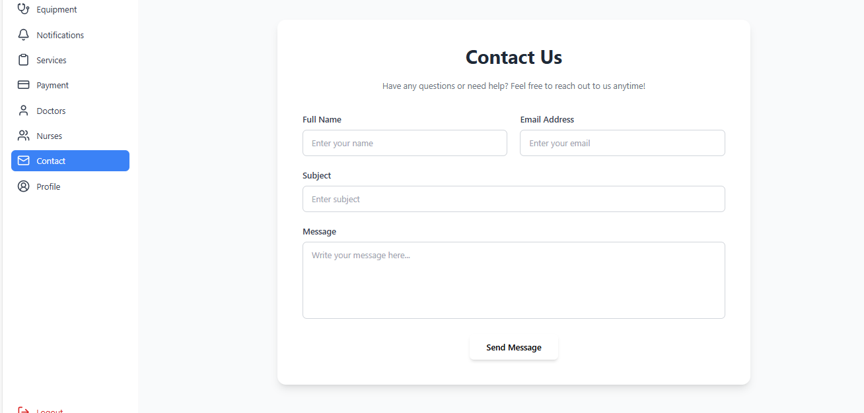

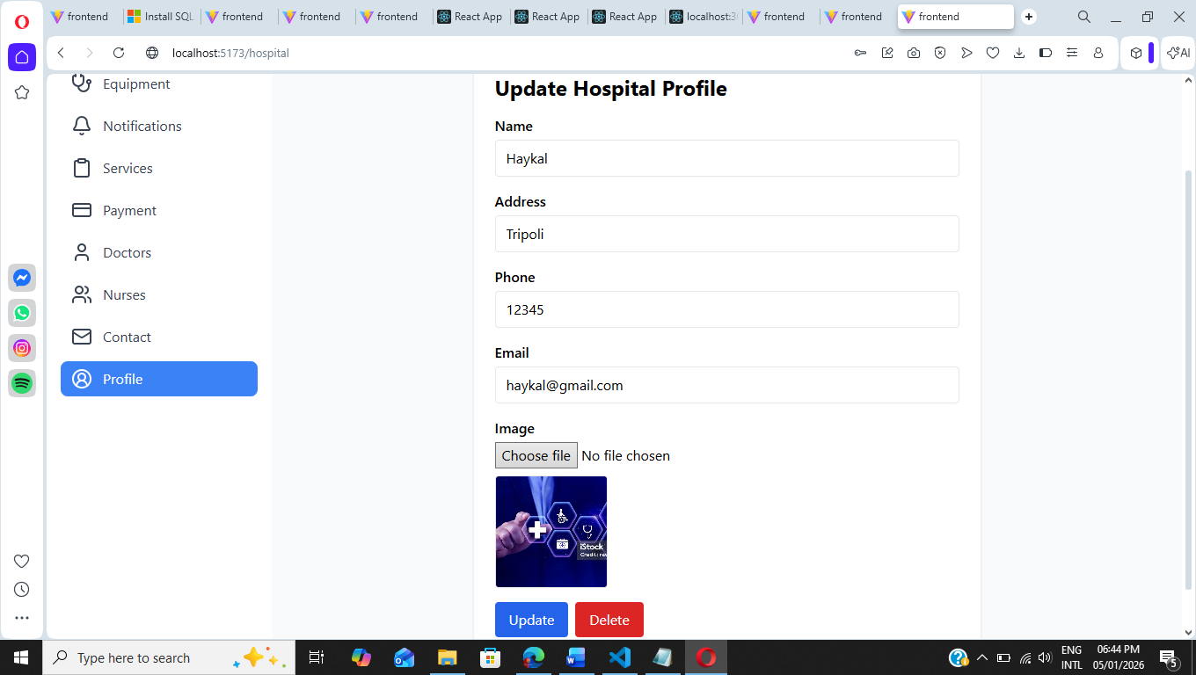
4.2.15- Admin Manage Users Page
in this page admin they can see available users registered and they can manage users include activate deactivate users and changing their roles from hospital to users and vise versa

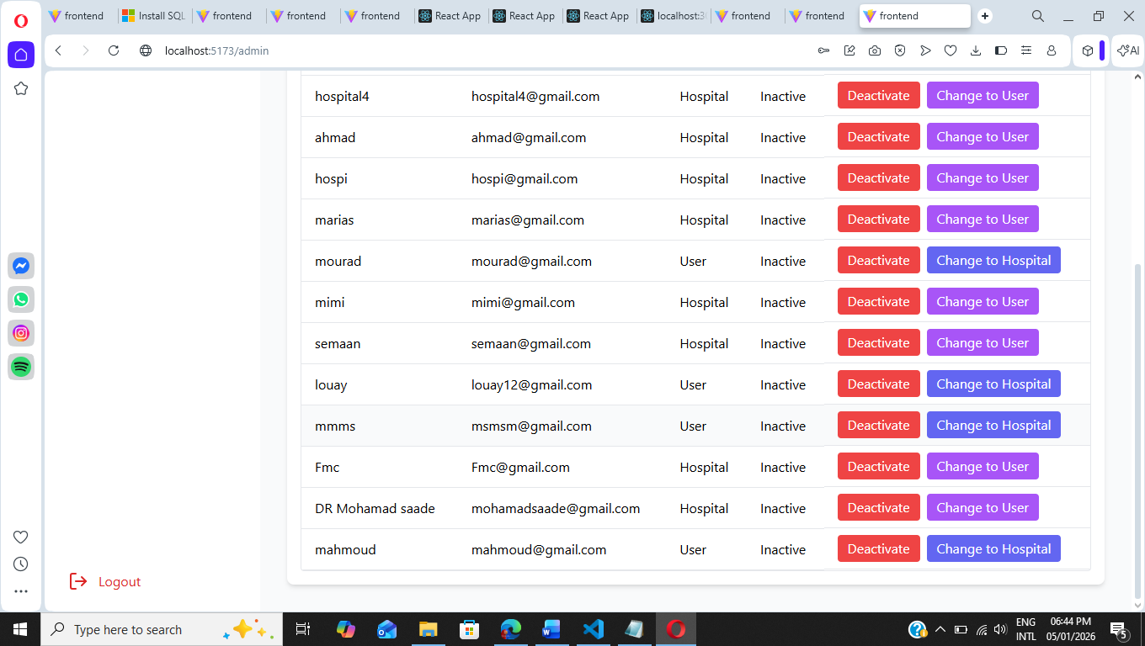
4.2.16- Manage Messages:
In this page admin they can manage and they can reply on it and the user will receive a notification based on reply messages

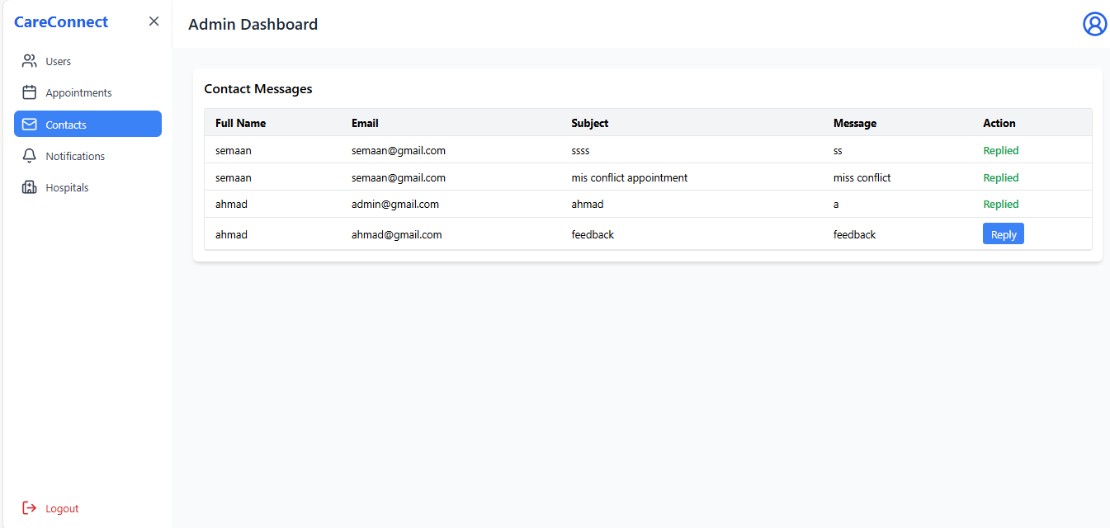

4.2.17- Manage Notifications Page
User they can see available Notification received and they can managed it include mark as read & delete
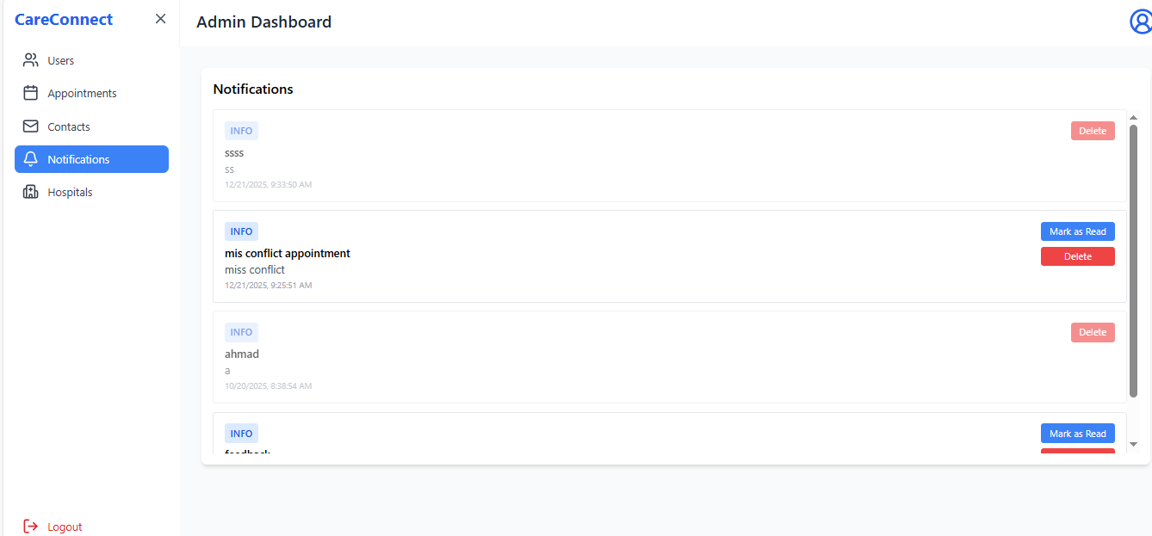

4.2.18- Manage hospitals:
In this Page admin they can update hospital profile information and they can delete it
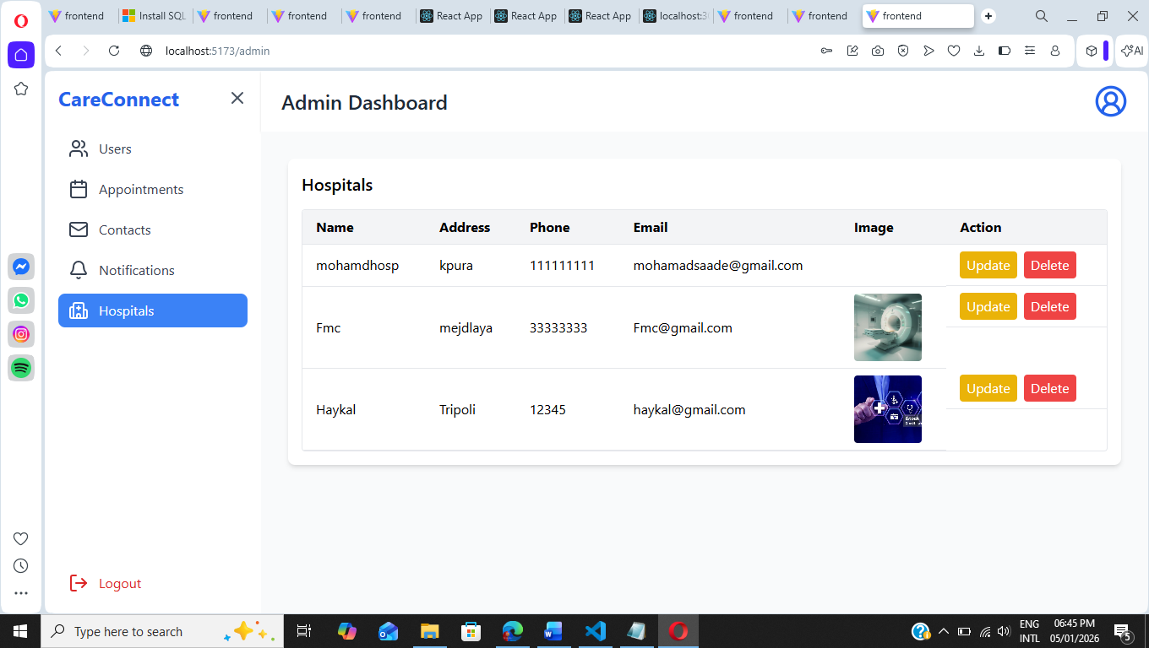

4.2.19 Login & Sign up Pages:

sign in signup page here user they can login if they have and account sign up if they haven’t an account

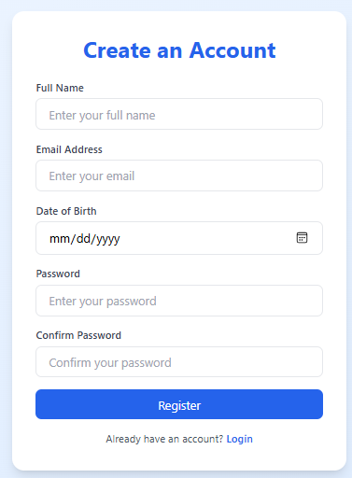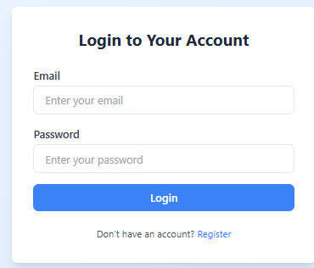

Chapter 5

Conclusion:

Care Connect Management System provides an effective digital solution for managing hospital operations and healthcare services.
The system centralizes appointment scheduling, role management, and communication between users, hospitals, and administrators.
It enables hospitals to manage their resources efficiently while offering users easy access to healthcare services.
Overall, the system improves operational efficiency, transparency, and the quality of healthcare service delivery.

Future Work:

Future enhancements may include integration with electronic medical records (EMR) systems.
Mobile application development for Android and iOS platforms can improve accessibility.
Advanced analytics and reporting tools can be added for better decision-making.
Security can be enhanced with multi-factor authentication and data encryption.
AI-based features such as smart appointment recommendations may also be implemented.

